The primary submission should be in two columns.
Generation of dynamic grids and computation of unsteady transonic flows around assemblies
Lizhi LU^{a,*}, John SMITH^{b}
ªDepartment of Aerodynamics, Tsinghua University, Beijing 100084, China
^{b}School of Electronic and Information Engineering, Duke University, Durham NC 27708, USA

Received x xxx 2020; revised x xxx 2020; accepted x xxx 2020
Abstract
（Abstract should be about 150-200 words which can conclude the whole content of the paper (including purpose, method, results and conclusion). Equations, figures and tables, as well as references are not supposed to appear in this part.)
The manufacture and maintenance of large parts in ships, trains, aircrafts, and so on create an increasing demand for mobile machine tools to perform operations. However, few mobile robots can accommodate the complex environment of industrial plants while performing machining tasks. This study proposes a novel six-legged walking machine tool consisting of a legged mobile robot and a portable parallel kinematic machine tool. The kinematic model of the entire system is presented, and the workspace of different components, including a leg, the body, and the head, is analyzed. A hierarchical motion planning scheme is proposed to take advantage of the large workspace of the legged mobile platform and the high precision of the parallel machine tool. The repeatability of the head motion, body motion, and walking distance is evaluated through experiments, which is 0.11, 1.0, and 3.4 mm, respectively. Finally, an application scenario is shown in which the walking machine tool steps successfully over a 250 mm-high obstacle and drills a hole in an aluminum plate. The experiments prove the rationality of the hierarchical motion planning scheme and demonstrate the extensive potential of the walking machine tool for operations on large parts.
Keywords: Legged robot; Parallel mechanism; Mobile machine tool; In-situ machining (about 5-8 words)

1. Introduction
(Begin each paragraph with an equal indentation of two typing spaces.)
The computation method of unsteady transonic flow based on N-S equations should be best accurate, but to three-dimensional complex problems, it can be achieved
only on large computers, and moreover, the results are not ideal sometimes. ¹ A viscous/inviscid interaction method is an applicable one and the computation time can be reduced by two orders.
(Equations, figures and tables are usually not supposed to appear in this part.)
2. Computation scheme
2.1. Governing equation
2.1.1. Principle
The unsteady full-potential equation written in a body fitted coordinate system is given by
(1)
where ρ is density, U, V, and W are the contravariant velocity components in the ξ, η, and ζ directions,means time, and J is Jacobian.
Eq. (1) is solved by the time-accurate approximate factorization algorithm and internal Newton iterations; ² body conditions and wake conditions are implicit embedded.
2.2. Generation of grids
Taking the incompressible potential flow round a cylinder for example, the stream function is
(2)
where a is radius, and the velocity of free stream. Magnifying its radius to .
3. Presentation of results
3.1. Artwork/Figure
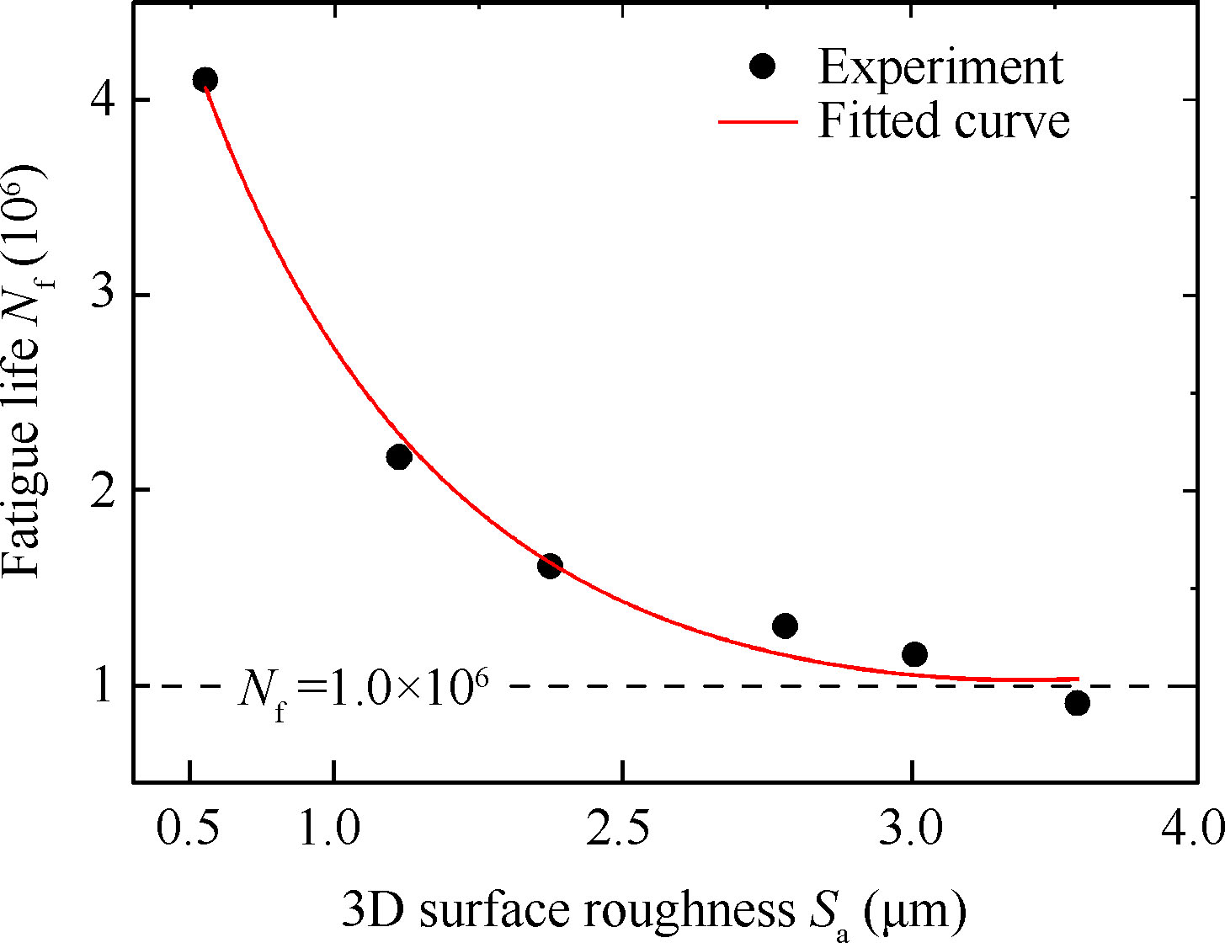
Fig. 1. Comparison between computation result and experimental data²⁴ for temperature distribution of inner wall of nozzle.

Table 1 CPU time ratio of each term.
Computational term | CPU time (%)
Flow field | 32.6
Solid temperature field | 2.2
Species concentration field | 4.3
Radiation transfer/energy field | 60.9
4. Conclusions
(1) A rapid method of the generation of boundary-fitted dynamic grids is developed in this paper, and the method of Viscous/Inviscid Interaction is used to compute the unsteady aerodynamic forces on wing/missiles and wing/body with control surfaces.
(2) The computation results are in agreement with experimental data.
Acknowledgements
This study was co-supported by the Open Fund of Key Laboratory of Power Research of China (No. *****) and the National Natural Science Foundation of China (Nos. ****** and ******).
References
Reference to journal
1. Van der Geer J, Hanraads JAJ, Lupton RA. The art of writing a scientific article. J Sci Commun 2000;163(1):51–59.
Reference to a book
2. Strunk Jr W, White EB. The elements of style. 3rd ed. New York: Macmillan; 1979. p. 5-10.
Reference to a chapter in an edited book
3. Mettam GR, Adams LB. How to prepare an electronic version of your article. In: Jones BS, Smith RZ, editors. Introduction to the electronic age. New York: E- Publishing Inc.; 1999. p. 281–304.
Conference paper
4. Christensen S, Oppacher F. An analysis of Koza's computational effort statistic for genetic programming. In: Foster JA, Lutton E, Miller J, Ryan C, Tettamanzi AG, editors. Genetic programming. EuroGP 2002: Proceedings of the 5th European conference on genetic programming; 2002 Apr 3-5; Kinsdale, Ireland. Berlin: Springer; 2002. p. 182-191.
Scientific or technical report
5. Russell ML, Goth-Goldstein R, Apte MG, Fisk WJ. Method for measuring the size distribution of airborne Rhinovirus. Berkeley (CA): Lawrence Berkeley National Laboratory, Environmental Energy Technologies Division; 2002. Report No.: LBNL49574.
Dissertation
6. Borkowski MM. Infant sleep and feeding: a telephone survey of Hispanic Americans [dissertation]. Mount Pleasant (MI): Central Michigan University; 2002.
Journal article on the Internet
Abood S. Quality improvement initiative in nursing homes: the ANA acts in an advisory role. Am J Nurs [Internet]. 2002 Jun [cited 2002 Aug 12]; 102(6): 51-9. Available from: http://www.nursingworld.org/AJN/2002/june/Wawatch.htmArticle
Article not in English
Liu JY. An improved SST turbulence model for hypersonic flows. Acta Aeronautica et Astronautica Sinica 2012;33(12):2192-2201 [Chinese].
Monograph on the Internet
Foley KM, Gelband H, editors. Improving palliative care for cancer [Internet]. Washington: National Academy Press; 2001 [cited 2002 Jul 9]. Available from: http://www.nap.edu/books/0309074029/html/
Homepage/Web site
Cancer-Pain.org [Internet]. New York: Association of Cancer Online Resources, Inc.; c2000-01 [updated 2002 May 16; cited 2002 Jul 9]. Available from: http://www.cancer-pain.org/
Appendix
(Appendix is put behind biography unless otherwise specified. If there is more than one, order them with capitalized letters. If there are equations, order them with letters and numbers, such as “(A1)” and “(A2)”.)

*Corresponding author. E-mail address: abc@163.com

